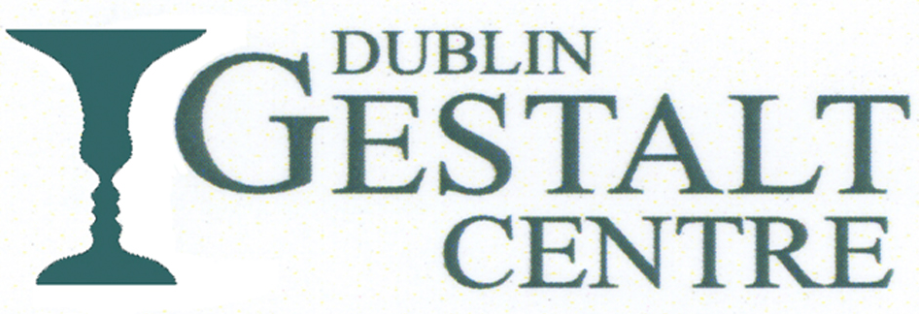

A Workshop with Rich Hycner Ph.D.
Therapeutic Artistry : Between Client and Therapist
The Workshop will include theory, demonstrations and discussion.
Date : 13th – 15th September 2019
9.30 to 5.30 Friday & Saturday, 9.30 to 1.00 Sunday
Venue : Avila, Bloomfield Avenue, Donnybrook, Dublin. D04 YF66.
Cost : €380. Includes Light Refreshments. Full Payment by 1st August.
Numbers limited to 30
Full Details and Application Form on our Website
www.gestalt.ie ; email : info@gestalt.ie

