Gestalt Associates Training Los Angeles

Dublin, October 11-13, 2019
Three-Day Contemporary Gestalt Therapy
Training Workshop for Therapists

Robert W. Resnick Ph.D.

& Rita F. Resnick, Ph.D.
International Trainers
with
Kevin McCann, H. Dip. GT & Favo Barbarello, M.Sc
(If registration warrants)

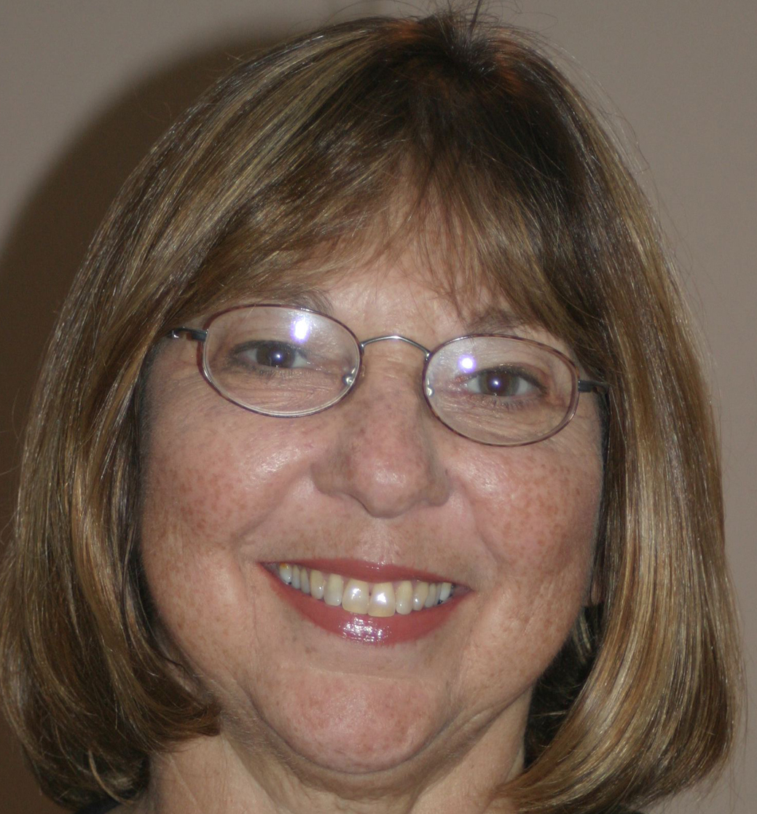
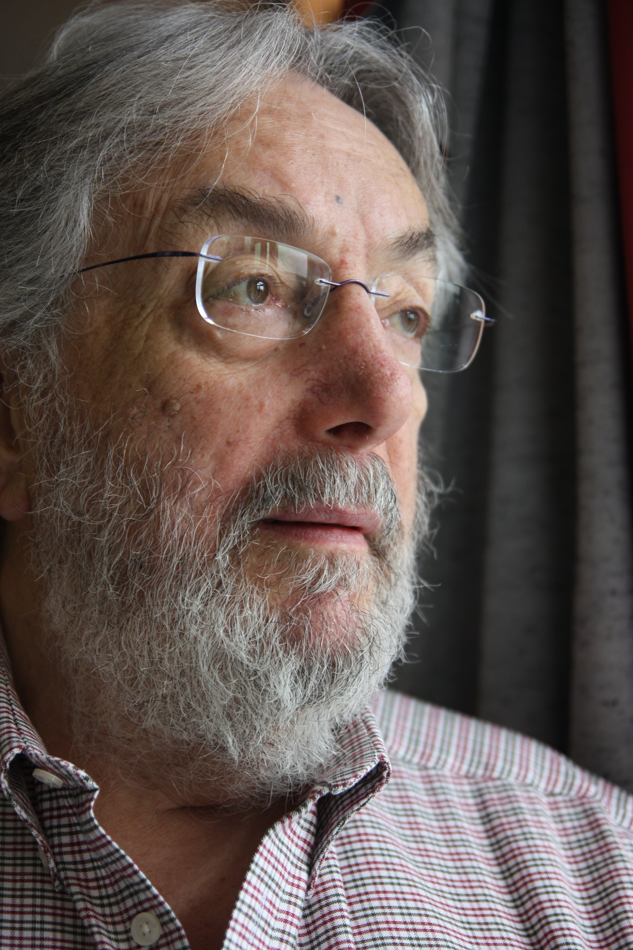

Bob and Rita Resnick invite therapists, counsellors and graduate students of all orientations to three days of Contemporary Gestalt Therapy training with theory and special emphasis on relating the live clinical work to the theory – making both more meaningful. The workshop will be both experiential and didactic training. The Resnicks are particularly skillful in distilling and presenting complicated theory in plain English in an integrative manner.

The workshop will begin with brief theory lectures encouraging questions, comments and comparisons with different psychotherapy models within Gestalt Therapy as well as outside of Gestalt Therapy (contemporary psychoanalytic, person centered, integrative, CBT, existential, systemic, post modern, “evidenced based”, etc.). This will be followed by “hands on” live clinical work with volunteer participants having the opportunities to work on their own personal issues with either Bob or Rita, or, to be therapist themselves with live supervision with one or both of the Resnicks. This is an opportunity to see world-renowned Gestalt Therapy trainers work live followed by comments, questions, discussion and comparisons. Theory, methodology and technique will all be addressed. An exquisitely process-oriented therapy, Gestalt Therapy maintains the flexibility to integrate new ideas and perspectives from many sources thereby encouraging continual perceptual reorganization while maintaining its updated evolving vitality.

Couples and Individual Therapy Film Screening and Discussion:
On Thursday evening, October 10, 2019 there will be a film screening and discussion with Rita and Bob Resnick of both actual couples and individual therapy sessions with real people, dealing with real issues, with real therapists and in real time. There is no extra charge for this screening for workshop participants. The screening is open to the public and especially therapists and students. See “Details” for location, times and cost (for non-workshop participants).

Biographies:

Rita F. Resnick, Ph.D., psychotherapist, has been Faculty Chair of GATLA’s European Summer Residential Training Programs since 1991. She is core faculty of both the Couples Therapy and Individual Psychotherapy training programs. In addition to her private practice, Rita is providing training in Couples and Individual therapy to psychotherapists and allied professionals in the United States, Australia, Europe and Asia. Her professional interests include the exploration of innovative and supportive approaches to supervision and a devoted, passionate (and self-serving) interest in the area of women growing older. Rita has published a chapter in Woman In Gestalt Therapy eds. Adriena Feckova, Beatrix Wimmer. The voice of female Gestalt therapists from Europe, USA and Israel who have contributed to the development of Gestalt therapy. The December 2018 issue of the British Gestalt Journal features Malcolm Parlett’s Interview with Rita and Bob about their model or relationships and couples therapy. Rita’s style is clear, empowering, thoughtful and caring. The Resnicks are frequently happily married.

Robert W. Resnick, Ph.D., Clinical Psychologist, Gestalt and Couples Therapist trainer for over 50 years was trained (1965-1970), and personally certified (1969) by Drs. Fritz Perls and James Simkin. Chosen by Fritz Perls to introduce Gestalt Therapy to Europe in the summer of 1969, he is an international Gestalt Therapy and Couples Therapy trainer and has been doing European training several times each year since 1969. Winner of the 2019 Distinguished Award for the International Advancement of Psychotherapy - American Psychological Association (APA), Division 29. Individual Gestalt Therapy demonstration films and Couples Therapy films (with Rita Resnick, Ph.D.) are available at vimeo.com/ondemand/gestaltfilms - 30% discounts for Gestalt people. His first clinical practicum was driving a New York taxicab. And yes, the Resnicks are frequently happily married.

Favorito Barbarello, M.Sc. Gestalt Psych., H. Dip. was born in Italy and has been living in Ireland since 1998. He trained initially as a craniosacral therapist, and subsequently started training in Gestalt psychotherapy at G.A.T.L.A. with Bob and Rita Resnick in 2004. For the last 7 years, Favo has been a teaching assistant in G.A.T.L.A. for both the Couples program and the Gestalt programs. Favo is also visiting faculty at several training centres in Europe, has a busy private practice in Ireland, and with his partner Kevin, runs workshops at home and away. Favo and Kevin set up the Irish Gestalt Training Institute in 2013.

Kevin McCann, H.Dip. (Hons) in Gestalt Therapy was born in Lurgan, Co Armagh, Northern Ireland He continued his training with Gestalt Associates Training Los Angeles (G.A.T.L.A.), becoming a certified Gestalt Therapist, becoming a Group Leader for GATLA in 2011. Kevin lectures extensively in Gestalt therapy, both in Ireland and abroad, and is a visiting lecturer at several Gestalt Institutes. He is an accredited supervisor, and has 30 years experience in third level education and training. Kevin is an accredited member of the Irish Association of Counseling and Psychotherapy and is a former chairperson of the Irish Gestalt society. Kevin also runs a private practice for individuals and couples.

Details :

Venue : Avila Retreat Center, Bloomfield Avenue, Donnybrook, Dublin 4, Ireland
Times: Thursday October 10, 2019, 7pm -9pm; Friday, Saturday, Sunday, October 11-13, 2019, 9.30am-5:00pm

Fee Workshop (including film screening): €400 (early bird €375 if paid before August 30, 2019)
Student Fee Workshop (including film screening): €300 (early bird €275 if paid before August 30, 2019)

Fee Film Screening Only : €20 to public or €10 students

Other Info :
Fee is exclusive of accommodation and meals. Tea and coffee will be provided at breaks and canteen facilities are available if you wish to bring your own food.

Ample free parking at Avila Centre.
A limited number of rooms are available at Avila on a bed and breakfast basis for at approximately €40 per night and can be booked by contacting 016430200 or info@avilacentre.ie
Certificates will be issued for 24.5 hours CPD.

Payment Details: Payment can be made directly at Brown Paper Tickets – which accepts either credit cards
https://resnickdublinworkshop.brownpapertickets.com

For further information about registration, contact BobResnick360@gmail.com

Cancellation Policy:
A €50 processing fee will be charged for cancellations made prior to September 1, 2019. There will be no refunds made for cancellations after September 1, 2019. In the unlikely event of the workshop being cancelled by the organizers a full refund will be made.

